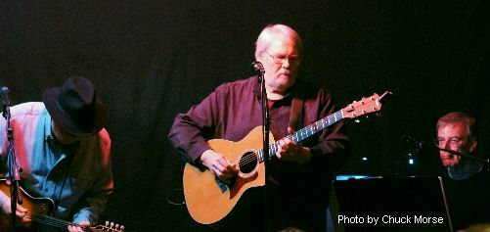

The Critics Rave…. about Rob Carlson (what a guy!)-

“I always look for a headliner who is not only a great
singer/songwriter, but who is someone who can entertain an audience for ninety minutes. If they happen to have a good sense of humor -that's a big plus. No one embodies these qualities any better than Rob Carlson.” Ron Sowell, Woody Hawley Concert series, Charleston, WV.

• “A big, lovable teddy bear of a man with a wicked sense of humor. His voice is warm and inviting…” - David Hurst “Show Business”

• “Rob Carlson is a scream…” Scott and Barbara Siegel, “Back Stage”.

• “The kind of sophisticated, grown up entertainment we like…” Miles Marek, Fairfield Theatre Company

• “... a refreshing change of pace from conventional pop product.”-- Billboard Magazine

• “If you want to have a terrific night out go see Rob Carlson. He’s bitingly clever, and his thoughtful side is very moving too. I’ve worked with this guy a couple of times now- he rips audiences up.” - Christine Lavin

• “...a sophisticated melange of songs and comedy, In short, Rob Carlson entertains.”-- Westport News

• “...unlike any other “folk” performer I have ever listened to. His style is refreshing, his versatility amazing.”-- The Fairfield Mirror (Fairfield University)

• “While most singers aren’t comedians and most comedians can’t sing, Rob Carlson accomplishes both feats...”-- Fairfield County Weekly

• “...Serious, joyful, irreverent, reflective and belly laugh funny.” -- The Norwalk Hour

• “Carlson’s songs are gems that sparkle with empathy and warmth.” -- FM Guide.

• “Carlson brought a refreshing taste of good-natured wit, warmth and general songwriting skill to the stage.”-- Danbury News-Times

• “... a multi-dimensional talent”-- The Bergen County Record

